Body Map – Female
Osabea Healthcare Solutions Ltd Staff must not carry out any physical inspection of Individuals if they have reason to suspect harm. This is the role of medical practitioners when there is a need.

The body map is for recording injuries that the Staff may have observed whilst carrying out their normal care and support activities. Where appropriate use this form to provide further information to support a safeguarding concern.
Record the area/site of any injury, marks, bruising, etc. Please also indicate the rough size in centimetres or use a comparison, for example, the same size as a 10p coin. Record details such as the colour of bruising, swelling and shape.
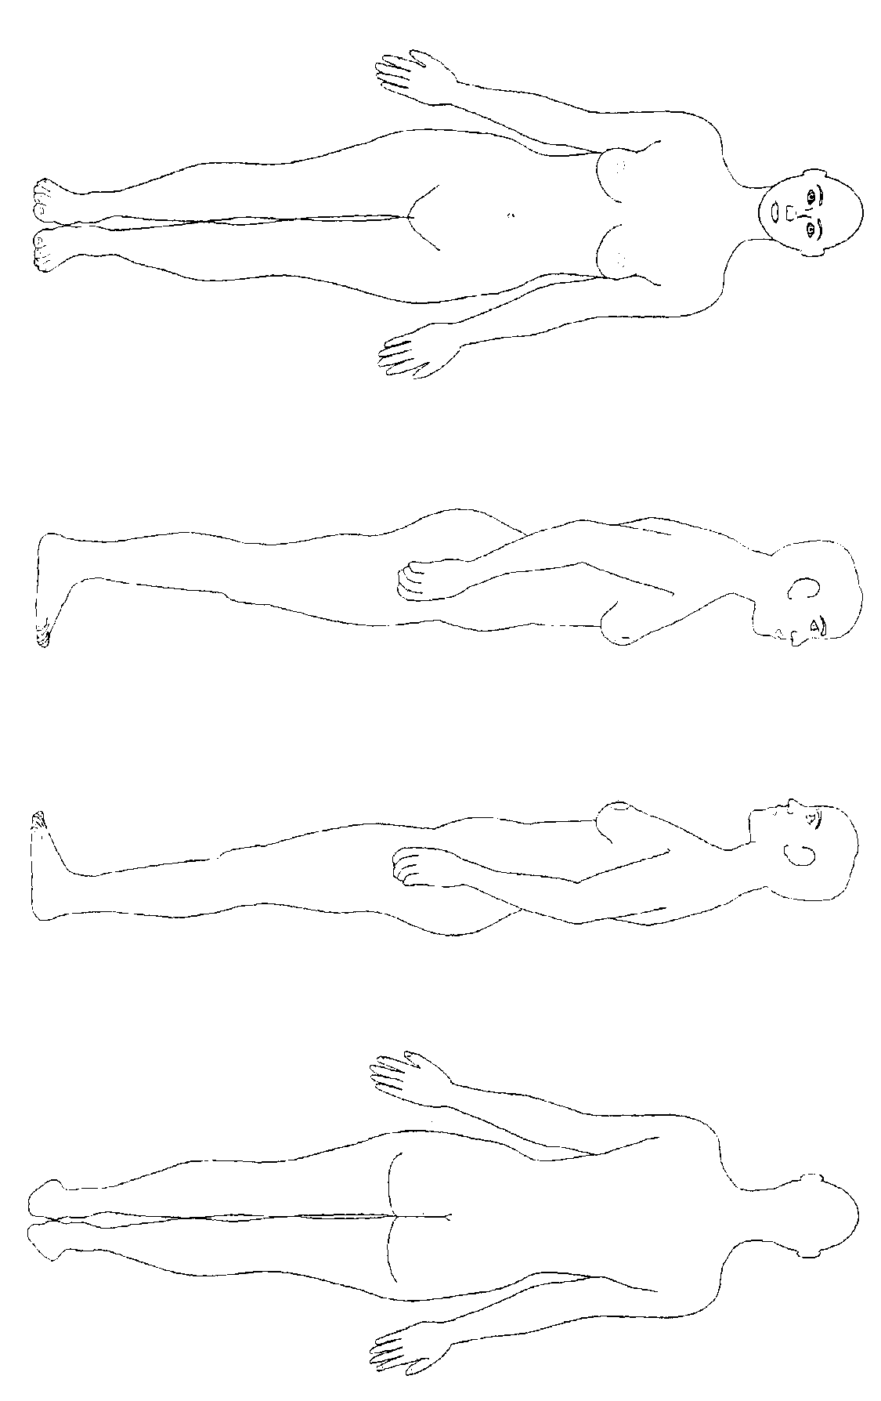

Name of Individual: | Date body map was completed:

Date of when injury occurred (if known): |  | Date body map was completed:

Name of Staff: | Date body map was completed:

Reported to: | Date body map was completed:

Additional information: | Date body map was completed:

